Title
Firstname Lastname ¹, Firstname Lastname ² and Firstname Lastname ^{2,}*
Received: date
Revised: date
Accepted: date
Published: date
Copyright: © 2025 by the authors. Submitted for possible open access publication under the terms and conditions of the Creative Commons Attribution (CC BY) license (https://creativecommons.org/licenses/by/4.0/).
¹ Affiliation 1; e-mail@e-mail.com
² Affiliation 2; e-mail@e-mail.com
* Correspondence: e-mail@e-mail.com.
Abstract: The abstract should consist of a single paragraph, with a maximum of 250 words. For research papers, it must provide a clear and concise summary of the study. Authors are encouraged to follow a structured format—without using section headings—that includes: (1) Background: setting the research question within a broader context and stating the study’s objective; (2) Methods: a brief explanation of the primary methods or interventions used; (3) Results: a summary of the key findings; and (4) Conclusions: the main interpretations or implications of the results. The abstract must objectively reflect the content of the manuscript, avoid including unreported data, and refrain from overstating the conclusions.
Keywords: keyword 1; keyword 2; keyword 3 (Choose three to five relevant keywords that accurately reflect the content of the article and are commonly used within the field of study)

0. Instructions for Using This Template
This template outlines the sections typically included in a manuscript. Each section is associated with a predefined style available in the 'Styles' menu in Microsoft Word. Optional sections are clearly indicated. While these section headings are designed for research articles, review papers and other formats may adopt a more flexible structure.
Please delete this paragraph and begin numbering from section 1. If you have any questions, feel free to reach out to the journal's editorial office.

1. Introduction
The introduction should concisely situate the research within a broader academic or practical context, explaining its relevance and importance. It needs to clearly state the objective of the study and underline its potential contributions. A thorough overview of the current developments in the relevant research area should be provided, supported by citations to key literature. When applicable, opposing views or debates within the field should also be acknowledged. The introduction should conclude by presenting the central research question or aim and a brief indication of the study’s key findings. Authors are encouraged to write the introduction in a way that remains accessible to readers from related disciplines. All references must be cited using the APA 7th edition citation style.

2. Materials and Methods
This section should provide a detailed description of the materials, procedures, and methods used, sufficient for other researchers to replicate or expand upon the work. By submitting your manuscript, you agree to make all related materials, datasets, codes, and protocols openly accessible to readers. Any limitations or restrictions regarding access to materials or data must be clearly stated at the time of submission. Newly developed methods should be thoroughly explained, while commonly used methods may be briefly summarized and supported with appropriate citations.
For research involving large datasets stored in public repositories, authors must specify the database used and provide the corresponding accession numbers. If these identifiers are not yet available at the time of submission, please indicate that they will be supplied during the review process and ensure they are included before final publication. For studies involving human or animal subjects or any research requiring ethical clearance, the approving institution and ethical clearance number must be clearly stated.
In addition, if generative artificial intelligence (GenAI) tools were used in any aspect of the study—such as generating content, analyzing data, or assisting with research design—this must be transparently disclosed in this section. Simple editorial use of GenAI (e.g., grammar or formatting corrections) does not require disclosure.

3. Results
This section may be divided by subheadings. It should provide a concise and precise description of the experimental results, their interpretation, as well as the experimental conclusions that can be drawn.

3.1. Subsection

3.1.1. Subsubsection
Bulleted lists look like this:
- First bullet;
- Second bullet;
- Third bullet.
Numbered lists can be added as follows:
- First item;
- Second item;
- Third item.
The text continues here.

3.2. Figures, Tables and Schemes
All figures and tables should be cited in the main text as Figure 1, Table 1, etc.
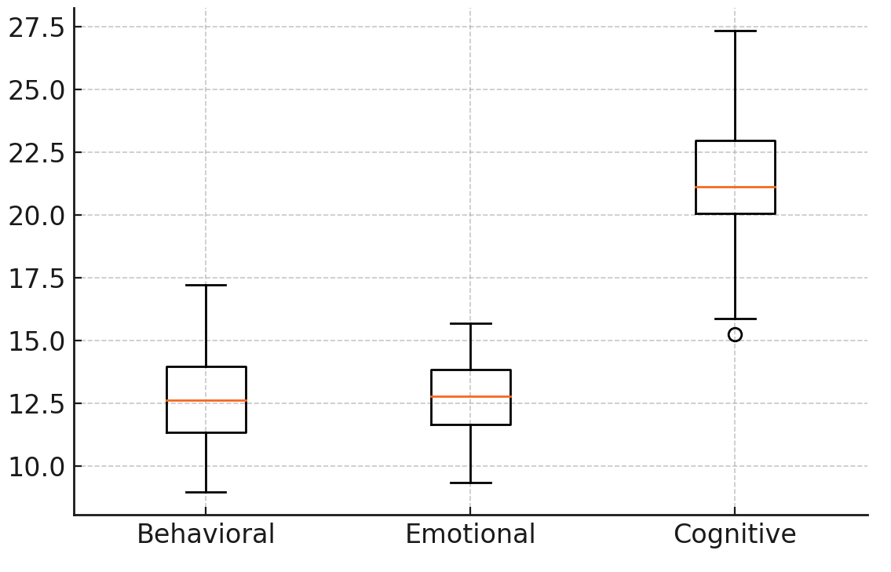
Figure 1. This is a figure. Schemes follow the same formatting.

Table 1. This is a table. Tables should be placed in the main text near to the first time they are cited.
Title 1 | Title 2 | Title 3
entry 1 | data | data
entry 2 | data | data ¹
¹ Tables may have a footer.

3.3. Formatting of Mathematical Components
This is example 1 of an equation:
a = 1, | (1)
the text following an equation need not be a new paragraph. Please punctuate equations as regular text.
This is example 2 of an equation:
a = b + c + d + e + f + g + h + i + j + k + l + m + n + o + p + q + r + s + t + u + v + w + x + y + z | (2)
the text following an equation need not be a new paragraph. Please punctuate equations as regular text.

4. Discussion
Authors are expected to interpret their findings in relation to existing literature and the initial hypotheses of the study. The discussion should place the results within a wider scholarly context, addressing their significance and broader implications. Authors are also encouraged to suggest potential directions for future research based on the outcomes of the study.

5. Conclusions
A conclusion needs to be discussed comprehensively. A conclusion is the core point of research findings and discussion. This section needs to be synthesized comprehensively, especially in terms of the author's critical evaluation of research findings. It is not merely a re-statement of the data or findings but a synthesis of key points as mentioned in the introduction, which eventually produces the “Results and Discussion” chapter so that there is compatibility. The prospects for developing research findings and the prospects for future research applications (based on findings and discussion) can also be added. The conclusion, of course, must be able to answer the research objectives. Remember, the length of the conclusion is only about 5% of the total content of the manuscript.

Author Contributions: For research articles with several authors, a short paragraph specifying their individual contributions must be provided. The following statements should be used “Conceptualization, X.X. and Y.Y.; methodology, X.X.; software, X.X.; validation, X.X., Y.Y. and Z.Z.; formal analysis, X.X.; investigation, X.X.; resources, X.X.; data curation, X.X.; writing—original draft preparation, X.X.; writing—review and editing, X.X.; visualization, X.X.; supervision, X.X.; project administration, X.X.; funding acquisition, Y.Y. All authors have read and agreed to the published version of the manuscript.
Funding: Please add: “This research received no external funding” or “This research was funded by NAME OF FUNDER, grant number XXX” and “The APC was funded by XXX”.
Data Availability Statement: We encourage all authors of articles published in this journal to share their research data. In this section, please provide details regarding where data supporting reported results can be found, including links to publicly archived datasets analyzed or generated during the study. Where no new data were created, or where data is unavailable due to privacy or ethical restrictions, a statement is still required.
Acknowledgments: In this section, you can acknowledge any support given which is not covered by the author contribution or funding sections. This may include administrative and technical support, or donations in kind (e.g., materials used for experiments). Where GenAI has been used for purposes such as generating text, data, or graphics, or for study design, data collection, analysis, or interpretation of data, please add “During the preparation of this manuscript/study, the author(s) used [tool name, version information] for the purposes of [description of use]. The authors have reviewed and edited the output and take full responsibility for the content of this publication.”
Conflicts of Interest: Declare conflicts of interest or state “The authors declare no conflicts of interest.” Authors must identify and declare any personal circumstances or interest that may be perceived as inappropriately influencing the representation or interpretation of reported research results. Any role of the funders in the design of the study; in the collection, analyses or interpretation of data; in the writing of the manuscript; or in the decision to publish the results must be declared in this section. If there is no role, please state “The funders had no role in the design of the study; in the collection, analyses, or interpretation of data; in the writing of the manuscript; or in the decision to publish the results”.

Appendix A

Appendix A.1
The appendix is an optional section that can contain details and data supplemental to the main text—for example, explanations of experimental details that would disrupt the flow of the main text but nonetheless remain crucial to understanding and reproducing the research shown; figures of replicates for experiments of which representative data is shown in the main text can be added here if brief, or as Supplementary data. Mathematical proofs of results not central to the paper can be added as an appendix.
Table A1. This is a table caption.
Title 1 | Title 2 | Title 3
entry 1 | data | data
entry 2 | data | data ¹

Appendix B
All appendix sections must be cited in the main text. In the appendices, Figures, Tables, etc. should be labeled starting with “A”—e.g., Figure A1, Figure A2, etc.

References
The references entry is arranged in alphabetical order. All that is referred to in the text must be listed in the reference list, and all written in the reference list must be referred to in the text. The author is obliged to list all the references validly according to the sources and DOI (digital object identifier), particularly for entries from journals. In the case of cities of publication, differences should be made in writing cities of the USA and cities outside the USA. For example, cities in the USA are listed together with the initials of the state; e.g.: for Boston of Massachusset: Boston, MA. All references and citations use the APA Style 7th Edition. For citation and reference managers, it is mandatory to use the Mendeley app. If there are information and explanations relating to the further clarification of the content of the manuscript citation is using footnotes.

Examples of reference entries:
(Type: book, author = publisher)
American Psychological Association. (2019). Publication manual of the American Psychological Association (7th Ed.). Washington, DC: Author.
(Type: e-book)
Bransford, J. D., Brown, A. L., & Cocking, R. R. (2005). How people learn: Brain, mind, experience, and school. https://www.nap.edu/catalog/9853/how-people-learn-brainmind-experience-and-school-expanded-edition.
(Type: edited book, two editors or more)
Tobias, S., & Duffy, T. M. (Eds.). (2009). Constructivist Instruction: Success or Failure? New York, NY: Routledge.
(Type: book section)
Idris, S., Tabrani ZA., Sulaiman, F., & Amsori. (2020). Emerging Perspectives and Trends in Innovative Technology for Quality Education 4.0. In Kusmawan et.al. (Eds.). Assessment of Critical Education Concepts in the Perspective of Islamic Education. London: Routledge, pp. 66-70.
(Type: book, in English translated into Indonesian, original title intact)
Schunk, D. H. (2012). Learning theories: An educational perspective (E. Hamdiah & R. Fajar, Trans.). Yogyakarta: Pustaka Pelajar. (Original work published 2012).
(Type: book, Indonesian, not translation, an original title retained)
Tabrani ZA. (2017). Menggugat Logika Nalar Rasionalisme Aristoteles. Yogyakarta: Mizan.
(Type: book, one author)
Tabrani ZA (2015). Persuit Epsitemology of Islamic Studies. Yogyakarta: Penerbit Ombak.
(Type: book, two authors)
Tabachnick, B. G., & Fidell, L. S. (2007). Using Multivariate Statistics (Fifth ed.). Needham Heights, MA: Allyn & Bacon.
(Type: book, three authors)
Walidin, W., Idris, S., & Tabrani ZA. (2015). Metodologi Penelitian Kualitatif & Grounded Theory. Banda Aceh: FTK Ar-Raniry Press.
(Type: journal article, online)
Patimah, S., & Tabrani ZA. (2018). Counting Methodology on Educational Return Investment. Advanced Science Letters, 24(10), 7087–7089. https://doi.org/10.1166/asl.2018.12414
Mohd Yusoff, M. Z., Hamzah, A., Fajri, I., ZA, T., & Yusuf, S. M. (2022). The Effect of Spiritual and Social Norm in Moral Judgement. International Journal of Adolescence and Youth, 27(1), 555–568. https://doi.org/10.1080/02673843.2022.2156799
(Type: journal article, if the doi doesn't exist, then there must be an article URL)
Idris, S., Tabrani ZA., Sulaiman, F., & Murziqin, R. (2020). The Role of KKNI Curriculum in Supporting the Development of Education at the LPTK UIN Sunan Kalijaga Yogyakarta. International Journal of Advanced Science and Technology, 29(6), 4011-4024. Retrieved from https://sersc.org/journals/index.php/IJAST/article/view/15765/7958
(Type: journal article, three authors)
Casey, E., Kudeva, R., & Rousson, A. (2018). Institutionalization of Religion in Schools to Intercultural Education. Jurnal Ilmiah Peuradeun, 6(1), 85-102. https://doi.org/10.26811/peuradeun.v6i1.215
(Type: journal article, 4 or more authors, all full names written)
Abdullah, A., Ismail, M., Yaacob, M., Kamarudin, M., Mohd Alwi, M., Muhammad, M., Wan Mohd Nasir, W., & Hilaluddin, N. (2019). A Qualitative Approach towards the Understanding of Managerial Employees in Islamic Organizations. Jurnal Ilmiah Peuradeun, 7(3), 589-600. https://doi.org/10.26811/peuradeun.v7i3.465
(Types: prosiding)
Retnowati, E. (2012, 24-27 November). Learning mathematics collaboratively or Individually. Paper presented at the The 2nd International Conference of STEM in Education, Beijing Normal University, China. https://stem2012.bnu.edu.cn/data/short%20paper/stem2012_88.pdf.
(Type: document, report: institution, government, organization)
NCTM (National Council of Teachers of Mathematics). (2000). Principles and Standards for School Mathematics. Reston, VA: Author.
(Type: document, legal texts, original terms written followed by translation)
Peraturan Presiden RI. No. 8. (2012). Kerangka Kualifikasi Nasional Indonesia. [Indonesian National Qualification Framework].
Peraturan Menteri Riset, Teknologi, dan Pendidikan Tinggi RI. No. 44. (2015). Standar Nasional Pendidikan Tinggi. [National Standards of Higher Education].

